Talk on Effective Reading Techniques
The Department of English organized a talk on ‘Effective Reading Techniques’ on 25th March 2019. A talk was delivered by in-house faculty, Associate Professor Dr Nirmala de Abreu. The session was conducted in AF-4 classroom. A total of thirty-five students attended the session conducted for SYBA SEC students (Syllabus-based) from 11.00 am onwards.
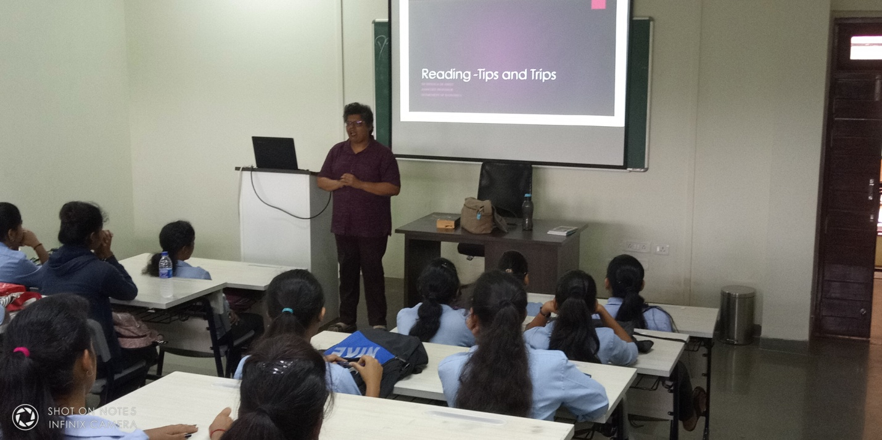
Resource person Dr Nirmala de Abreu delivering a talk
Dr Nirmala briefed students on the importance of reading, types of reading material, components of reading, how to improve one’s reading, reading strategies, do and don’ts of reading, note-taking, etc.
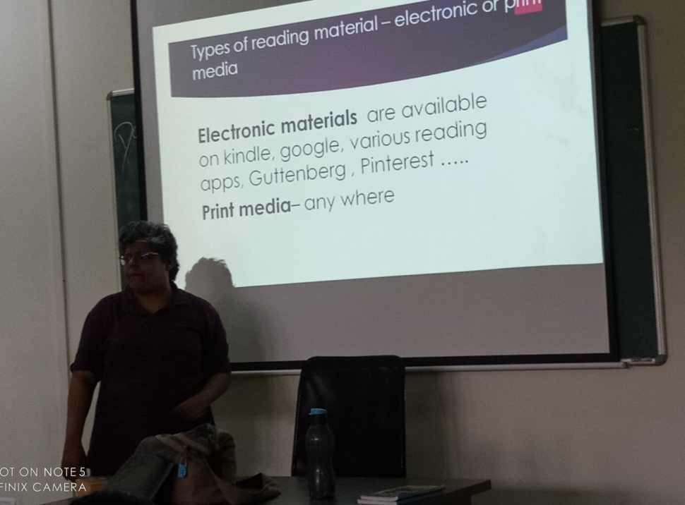 Oscar de Noronha,
Head, Department of English

